Website Creation Basics
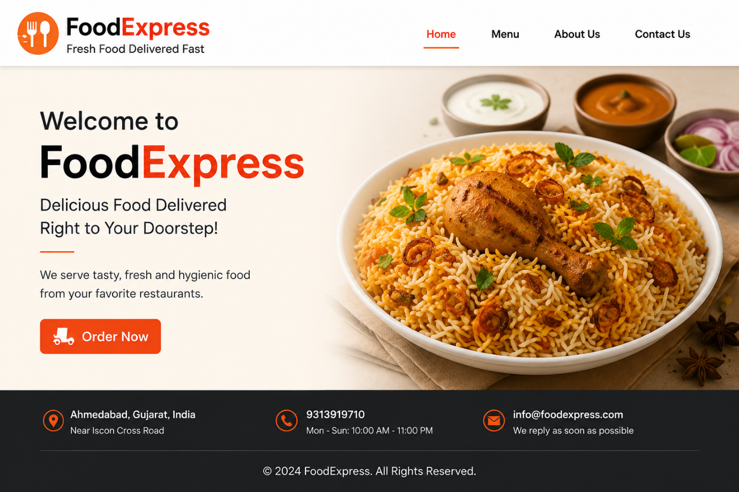
- Create a basic homepage for a fictional food delivery startup using HTML, including a header with the company name, a section introducing the service, and a footer with contact info.

- Add three images of popular dishes to your homepage using the <img> tag, and write a short description below each image.
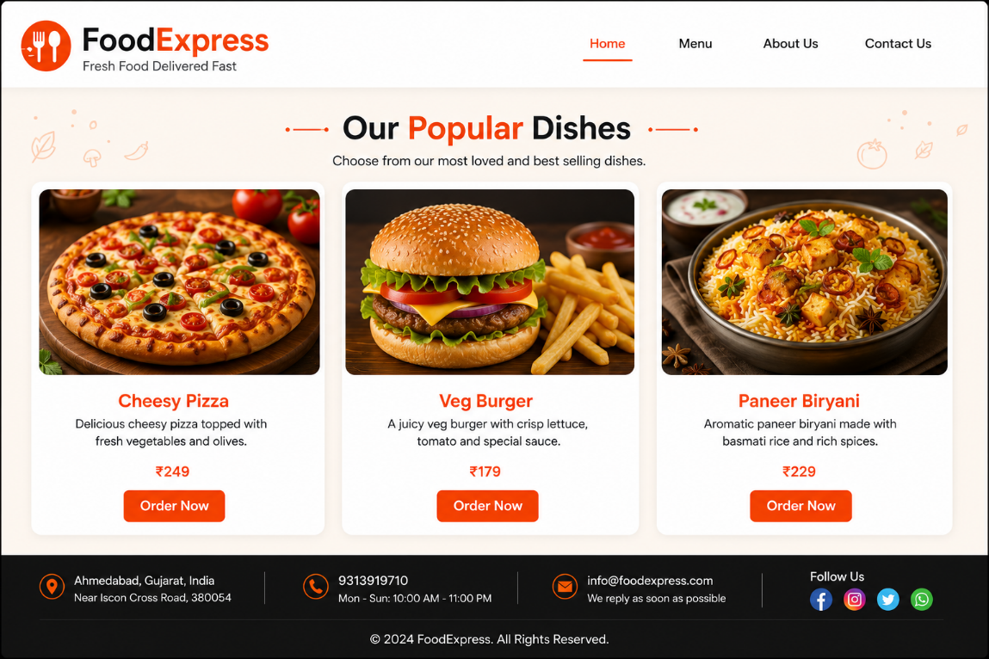
- Create a navigation menu at the top of your homepage with links labeled Home, Menu, and Contact Us; clicking each link should scroll to the respective section on the same page.

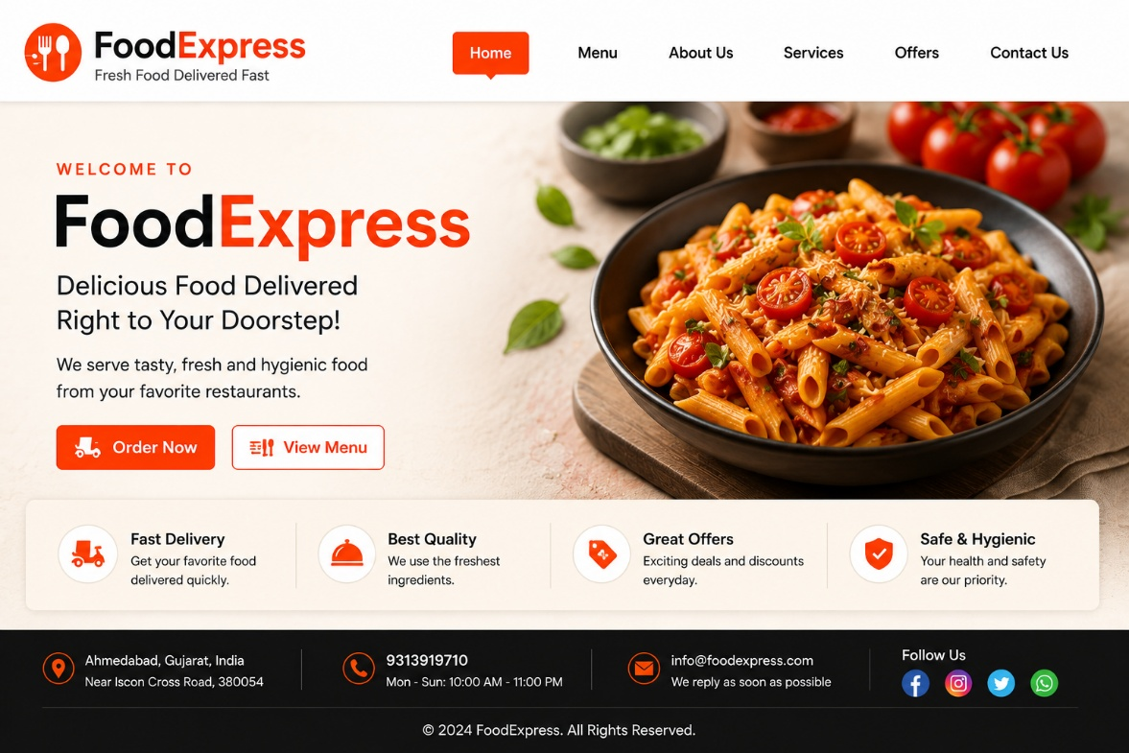

- Add a simple contact form at the bottom of your homepage with fields for Name, Email, and Message, and a Submit button. The form does not need to actually send data.
